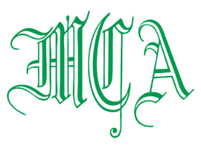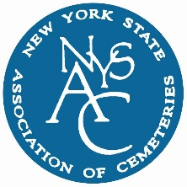
EVENT DATE:
THURSDAY, JANUARY 18, 2018
EVENT SNOW DATE
TUESDAY, JANUARY 30, 2018
LOCATION
WESTCHESTER MANOR

WWW.WESTCHESTERMANOR.COM
TEL: (914) 478-2331
(DIRECTIONS ON REVERSE SIDE)
THANK YOU ALL EXPO SPONSORS!
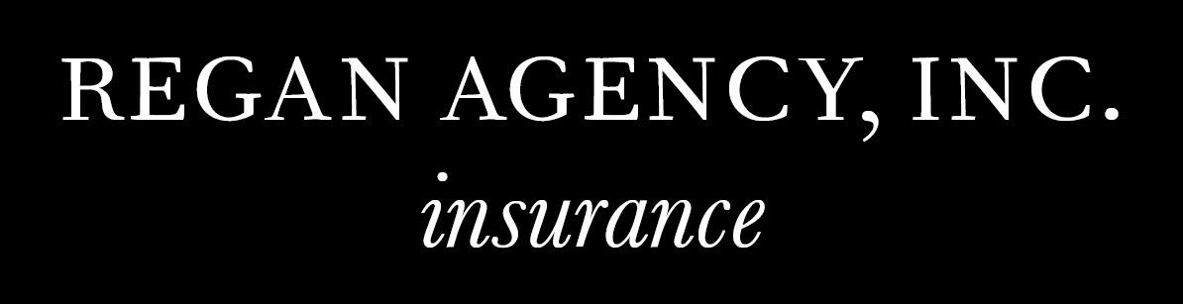
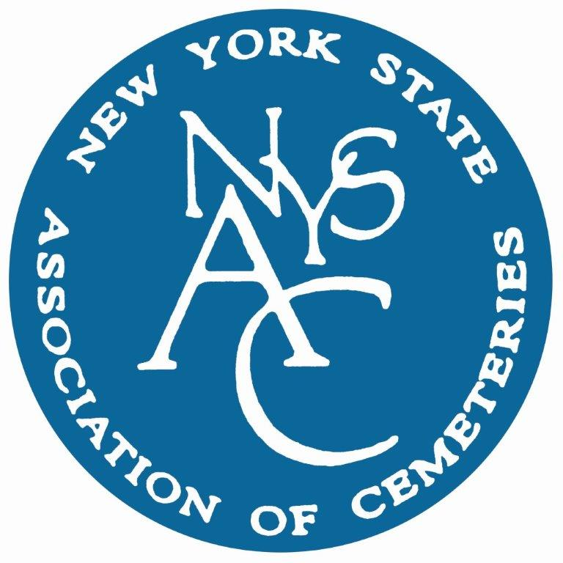
111 Washington Avenue
Suite 501
Albany, NY 11210
518-434-1134
518-427-0452 (fax)
info@nysac.com
www.nysac.com

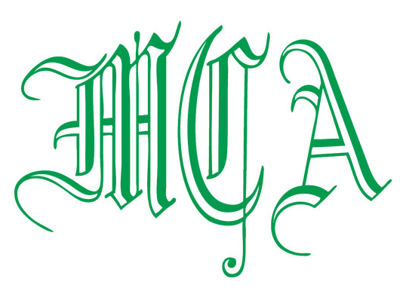

EXECUTIVE COMMITTEE

President
THERESA M. JOYCE- Mount Hope Cemetery Association

Vice President
JOHN HELLY- Flushing Cemetery

Secretary-Treasurer
JAN NEUMAN-Mount Lebanon Cemetery

DIRECTORS

ERIC BARNA- The Green-Wood Cemetery
KEVIN BOYD-Ferncliff Cemetery Association
ANTHONY DESMOND-Cypress Hills Cemetery
RITA GAMBINO- St. Michael’s Cemetery
JAMES GARLAND- Woodlawn Cemetery
JUSTIN LOCKE- Pinelawn Memorial Park

Past President
DENNIS WERNER – St. Michael’s Cemetery
Contact us all at:
my-mca-board@my-mca.org

2018 ANNUAL MCA & NYSAC CEMETERY EXPOSITION
WESTCHESTER MANOR
140 SAW MILL RIVER ROAD
HASTINGS-ON-HUDSON, NY 10706

The Metropolitan Cemetery Association and New York State Association of Cemeteries are taking part in the Third Annual Joint Cemetery Exposition which will be held on January 18th at the Westchester Manor. Please mark your calendars.

CO-CHAIRS: JAN NEUMAN, ERIC BARNA, RITA GAMBINO, MITCH ROSE, JOANNE SULLIVAN

EVENT DATE: JANUARY 18TH, 2018 (SNOW DATE JANUARY 30TH, 2018)
COST: $25.00 CEMETERY MEMBER IN ADVANCE
$60.00 DAY OF EVENT – PAYMENT AT THE DOOR
$200.00 SUPPLIER MEMBER – INCLUDES REGISTRATION FOR ONE PERSON & ONE EXHIBIT TABLE
$60.00 ADDITIONAL SUPPLIER MEMBER

RSVP: January 11, 2018
PROGRAM AGENDA:
9:00 am Registration
Continental Breakfast with Suppliers – Sponsored by Regan Agency

10:00 am Pledge of Allegiance
Welcome

10:15 am Poul Lemasters – Lemasters Consulting “Top 10 Cemetery Mistakes” – Little Mistakes That Turn Into Grave Problems

11:00 am Robert P. Miata- Consolidated Risk Management - Introduction to Excavation
Certification Class

11:15 am Break with Supplier Members & Exhibition
11:45 am Poul Lemasters – “Cremation Issues for Cemeteries” – Making Sure You Cover Your Assets
12:30 pm Lunch – Sponsored by Fenimore Asset Management
1:15 pm Cookies & Coffee – Supplier Door Prize Raffle and Representatives from the Division of Cemeteries, NYSAC Featherstonhaugh, Wiley and Clyne, and NYS Office of General Services/Procurement Services will be on hand to answer questions.
We also thank the following General Sponsors: Consolidated Risk Management, Behar Mapping, Creter Vault and Merendino Cemetery Care.
Supplier Members are invited to bring a gift to be raffled at their table during the event
Please respond & submit this registration form by January 11, 2018
Name of Cemetery/Supplier: _____________________________________________
Cemetery Attendees @ $25.00 1._______________ 2._______________
Table @ $200.00 3._______________ 4._______________
Supplier Attendees @ $60.00 5._______________ 6._______________
(Includes one attendee) 7._______________ 8._______________
___________________________________________________________________________________________________
Please make all checks payable to the following:
METROPOLITAN CEMETERY ASSOCIATION
Jan A. Neuman, MCA Registrations
Mt. Lebanon Cemetery
78-00 Myrtle Avenue, Glendale, NY 11385
PLEASE DO NOT SEND OR MAKE CHECKS PAYABLE TO NYSAC

