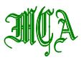

**METROPOLITAN CEMETERY ASSOCIATION**

**ANNUAL FISHING TRIP**

Thursday, August 16, 2018

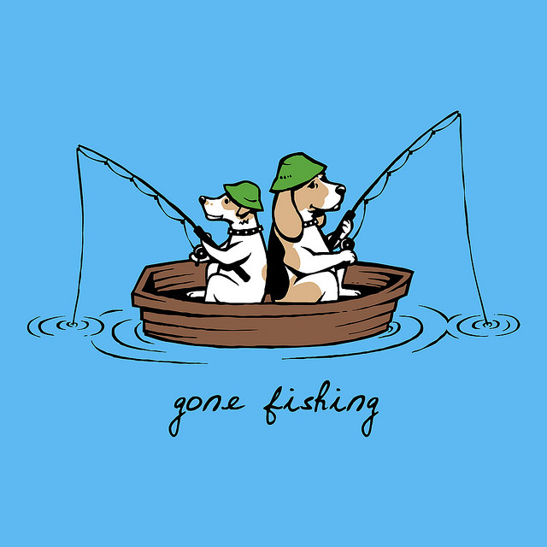

7:30AM Sharp: BOARDING TIME ON CAPTAIN LOU’S PARTY BOAT

28a WOODCLEFT AVE. FREEPORT, L.I., NY 11520

516-623-5823 *PARKING ACROSS THE STREET*

12 NOON CAPTAIN LOU’S PARTY BOAT RETURNS TO DOCK

12:30PM LUNCHEON WILL BE HELD AT E.B. ELLIOTT’S

23 WOODCLEFT AVE., FREEPORT, L.I., NY 11520

516-378-8776 *NEXT TO CAPTAIN LOU’S

**PLEASE RESPOND BY AUGUST 12, 2018**

NAME OF PERSON(S) ATTENDING:

_________________________________ _________________________________

_________________________________ _________________________________

CEMETERY OR SUPPLIER’S NAME: __________________________________________

# ATTENDING FISHING AND LUNCHEON_______@ $75 EA. $_________

# ATTENDING LUNCH ONLY _______@ $40EA. $_________

**MAKE CHECK PAYABLE TO: METROPOLITAN CEMETERY ASSOCIATION**

**Mail To: JAN NEUMAN**

**MCA REGISTRATIONS**

**MT. LEBANON CEMETERY**

**78-00 MYRTLE AVE.**

**GLENDALE, NY 11385**