A

METROPILITAN

CEMETERY
ASSOCIATION, INC

Association of Cemetery Officials
Of the Metropolitan Area of
New York

EXECUTIVE COMMITTEE

PRESIDENT
JOHN HELLY
Flushing Cemetery
163-06 46th Avenue
Flushing, NY 11358
(718) 359-0100
president@my-mca.org

VICE PRESIDENT
ANTHONY DESMOND
Cypress Hills Cemetery
833 Jamaica Avenue
(718) 277-2900
Vice-president@my-mca.org

SECRETARY-TREASURER
JAN NEUMAN
Mount Lebanon Cemetery
7800 Myrtle Avenue
Glendale, NY 11385
(718) 821-0200
secretary-treasurer@my-mca.org

DIRECTORS

KEVIN BOYD
Ferncliff Cemetery Association
(914) 693-4700

JAMES GARLAND
Woodlawn Cemetery
(718) 920-0500

JUSTIN LOCKE
Pinelawn Memorial Park
(631) 249-6100

RITA GAMBINO
Saint Michael’s Cemetery
(718) 278-3240

ERIC BARNA
The Green-Wood Cemetery
(718) 768-7300

THERESA DORAN
The Kensico Cemetery
(914) 949-0347

PAST PRESIDENT
THERESA M. JOYCE
Mount Hope Cemetery Association
PO Box 248
Hastings-on-Hudson, NY 10706
(914) 478-1855
pastpresident@my-mca.org

Contact us all at:

my-mca-board@my-mca.org

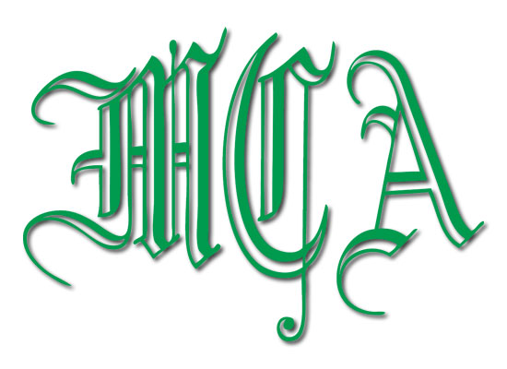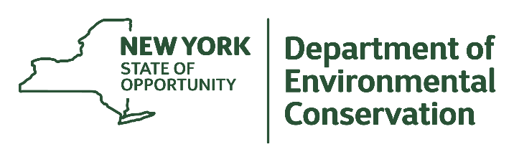

MCA Fall Business Meeting – Co-Sponsored By NYS Department of Environmental Conservation
Co-Chairs Eric Barna, Rita Gambino, Theresa Doran

Date: Wednesday, October 10, 2018

Place: THE GREEN-WOOD CEMETERY
500 25th Street Brooklyn, NY 11232
(718) 768-7300
(Please use main entrance located at 25th Street and Fifth Avenue)
Cost: $ 40.00 per person in advance
$ 60.00 per person at the door

RSVP: By September 27, 2018

Program Schedule

8:00 Registration
Coffee & Danish

9:00 Welcome/Pledge of Allegiance
Government Affairs & Legislative Update
9:30 NYS Division of Cemeteries: Lewis Polishook, Director
9:45 Introduction by NYSDEC: Ken Scarlatelli (DEC) & Joseph Charap (GW)
10:00 Expanding Sustainability in Cemetery Landscape Operations: Dennis Collins (Mount Auburn Cemetery)
10:30 New York State Department of Environmental Conservation Urban Forestry Grant Opportunities: Mary Kramarchyk (DEC)
11:00 Nature Goals 2050 / Habitat Opportunities: Bram Gunther
(NYC Parks/Natural Areas Conservancy) / Susan Elbin (NYC Audubon)

11:30 Climate Resilient Cemetery Grassland Management: Frank Rossi (Cornell
University) & Joseph Charap (GW)

12:00 Q&A/Discussion/Lunch

Event Sponsors New York State Department of Environmental Conservation, Metropolitan Cemetery Association and The Green-Wood Cemetery

Please respond by Name of Cemetery/Supplier:____________________________
Persons Attending
1.____________ 3.____________ 5.____________
2.____________ 4.____________ 6.____________
Persons Attending ____ @ $40.00 Total $________
Make checks payable to Metropolitan Cemetery Association
Mail to: Metropolitan Cemetery Association
c/o Jan Neuman, Mount Lebanon Cemetery
7800 Myrtle Avenue, Glendale, NY 11385-7494

