A
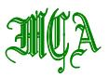

EXECUTIVE COMMITTEE

PRESIDENT
JOHN HELLY
Flushing Cemetery
163-06 46th Avenue
Flushing, NY 11358
(718) 359-0100
president@my-mca.org

VICE PRESIDENT
ANTHONY DESMOND
Cypress Hills Cemetery
833 Jamaica Avenue
(718) 277-2900
Vice-president@my-mca.org

SECRETARY-TREASURER
THERESA DORAN
The Kensico Cemetery
273 Lakeview Avenue
Valhalla, NY 10595
(914) 949-0347
secretary-treasurer@my-mca.org

DIRECTORS

KEVIN BOYD
Ferncliff Cemetery Association
(914) 693-4700

JAMES GARLAND
Woodlawn Cemetery
(718) 920-0500

JUSTIN LOCKE
Pinelawn Memorial Park
(631) 249-6100

RITA GAMBINO
Saint Michael’s Cemetery
(718) 278-3240

ERIC BARNA
The Greenwood Cemetery
(718) 768-7300

ADAM J. GINSBERG
Cedar Grove Cemetery Association
(718) 939-9405

PAST PRESIDENT
THERESA M. JOYCE
Mount Hope Cemetery Association
PO Box 248
Hastings-on-Hudson, NY 10706
(914) 478-1855
pastpresident@my-mca.org

Contact us all at:

my-mca-board@my-mca.org

2019 Holiday Luncheon
Rita Gambino, Eric Barna and Adam Ginsberg Co-Chairs
Premier Event Sponsor:

Date: Friday, December 6, 2019

Place: New Hyde Park Inn
214 Jericho Turnpike
New Hyde Park, NY 11040
www.innatnhp.com
General Event Sponsor:
Cost: $70 per person in advance
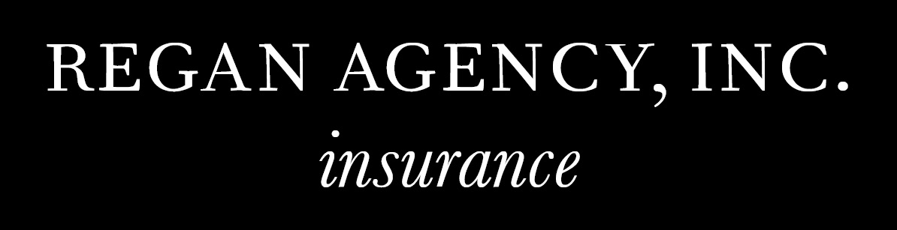
$85 per person at the door

RSVP: November 28, 2019

Program Schedule

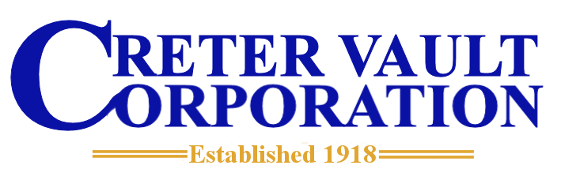
10:00 AM Registration, Coffee and Danish
Breakfast sponsored by:

11:00 AM Welcome
Pledge of Allegiance
MCA Update by John Helly, President
Government & Legal Affairs Legislative Update by Kevin Boyd
Lewis Polishook, Director, New York State Division of Cemeteries Report

11:30 AM Guest Speaker:
Marc Yearsley, Ensure-A-Seal
“How the Death Care Industry is Written About in the Media”

12:00 PM Lunch and Entertainment
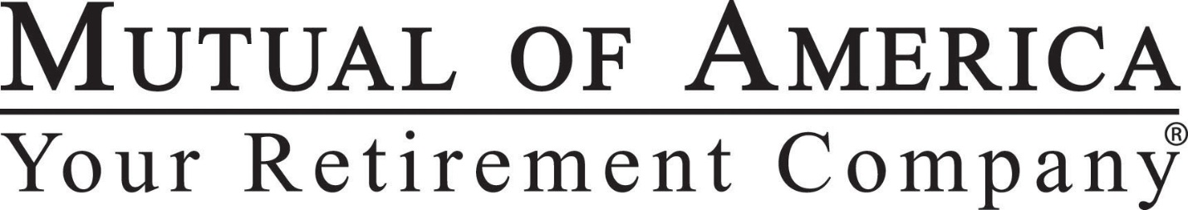
Holiday music provided by “Gary the DJ”
Lunch sponsored by

WE WILL HAVE TWO RAFFLES THIS YEAR
Free Raffle – Bring your door prize & 50/50 Raffle – Proceeds to Benefit:
Special Olympics – Tickets 1 for $10 or 3 for $25

Please respond by Nov 28, 2019 Name of Cemetery/Supplier:__________________________________
Persons Attending
1._______________________ 3. _______________________ 5. _______________________
2._______________________ 4. _______________________ 6. _______________________
Persons Attending ____ @ $70.00 Total $__________

Make checks payable to Metropolitan Cemetery Association
Mail to: Metropolitan Cemetery Association
c/o Theresa Doran, The Kensico Cemetery
P.O. Box 7, Valhalla, NY 10595

