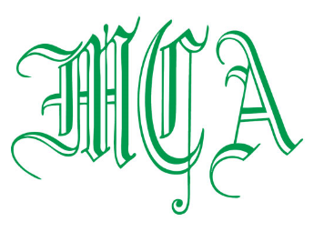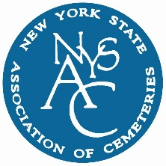

**THANK YOU ALL**

**EXPO SPONSORS!**





**EXECUTIVE COMMITTEE**

**PRESIDENT**

JOHN HELLY

Flushing Cemetery

163-06 46th Avenue

Flushing, NY 11358

(718) 359-0100

[**president@my-mca.org**](mailto:president@my-mca.org)

**VICE PRESIDENT**

ANTHONY DESMOND

Cypress Hills Cemetery

833 Jamaica Avenue

(718) 277-2900

[**Vice-president@my-mca.org**](mailto:Vice-president@my-mca.org)

**SECRETARY-TREASURER**

THERESA DORAN

The Kensico Cemetery

273 Lakeview Avenue

Valhalla, NY 10595

(914) 949-0347

[**secretary-treasurer@my-mca.org**](mailto:secretary-treasurer@my-mca.org)

**DIRECTORS**

KEVIN BOYD

Ferncliff Cemetery Association

(914) 693-4700

JAMES GARLAND

Woodlawn Cemetery

(718) 920-0500

JUSTIN LOCKE

Pinelawn Memorial Park

(631) 249-6100

RITA GAMBINO

Saint Michael’s Cemetery

(718) 278-3240

ERIC BARNA

The Greenwood Cemetery

(718) 768-7300

ADAM J. GINSBERG

Cedar Grove Cemetery Association

(718) 939-9405

**PAST PRESIDENT**

THERESA M. JOYCE

Mount Hope Cemetery Association

PO Box 248

Hastings-on-Hudson, NY 10706

(914) 478-1855

**pastpresident@my-mca.org**

**2020 ANNUAL MCA & NYSAC CEMETERY EXPOSITION**

Kevin Boyd, John Helly, Anthony Desmond, Philip Tassi and Brendan Boyle

The Metropolitan Cemetery Association and New York State Association of Cemeteries are taking part in the Fifth Annual Joint Cemetery Exposition which will be held on January 23rd at the Westchester Manor.

EVENT DATE: January 23rd, 2020 (**SNOW DATE** January 30TH, 2020)

LOCATION: Westchester Manor

140 Saw Mill River Road

Hastings-On-Hudson, NY 10706

COST: **$50.00** Cemetery Member in advance

**$60.00** Cemetery Member at the door

**$225.00** Supplier Member (Includes one registration and exhibit table)

**$60.00** Additional Supplier Members

RSVP: January 10, 2020

**PROGRAM AGENDA**:

9:00 am Registration

Continental Breakfast with Suppliers – Sponsored by

10:00 am Pledge of Allegiance

Welcome

10:15 am John Bolton – President, Blackstone Cemetery Development

“REAL ROI Behind Successful Garden Developments”

11:00 am Break with Supplier Members & Exhibition

11:45 am Dennis D’Andrea – Senior Business Analyst, ACE Workforce Technologies “Timely Payroll and HR Compliance Issues”

12:15 pm Buffet Lunch

We also thank the following General Sponsors: Mutual of America and The Davey Tree Expert Company

***Supplier Members are invited to bring a gift to be raffled at their table during the event***

***Exhibit tables for Supplier Members must be reserved in advance***

**­­­­­­­­­­­­­­­­­­­­Please respond & submit this registration form by January 10, 2020**

Name of Cemetery/Supplier: _____________________________________________

Attendees: 1. _______________ 2._______________ *Cemetery Attendees: $50 each*

3._______________ 4._______________ *Supplier with Table: $225*

5._______________ 6._______________ *Additional Suppliers: $60 each*

7._______________ 8._______________ Total: _______________

**_______________________________________________________________________________________**

*Please make all checks payable to the following:*

**METROPOLITAN CEMETERY ASSOCIATION**

c/o Theresa Doran

The Kensico Cemetery

P.O. Box 7

Valhalla, NY 10595

**PLEASE DO NOT SEND OR MAKE CHECKS PAYABLE TO NYSAC**